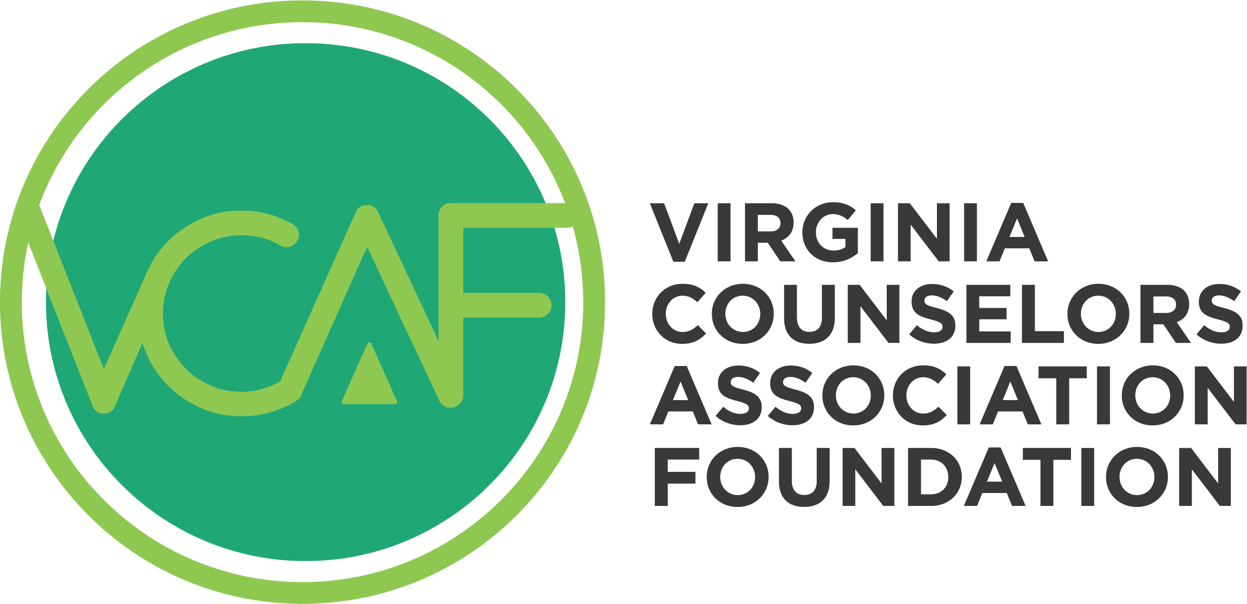

Pete Warren Student Fellows

2024 Scholarship Application

Directions:

- Please complete the required information below, including the essay,
- Save the Word document to your computer with the title as your last name, first name.
Create an email to Linda Grubba at Grubba_L@lynchburg.edu, and
- Attach a copy of the final document(s) to the email,
- Submit your document no later than 11:59 p.m. on Friday, March 1, 2024.

Applicants will receive an email confirming receipt of their application. Applicants will receive a message regarding the decision by March 29th, 2024.

Part I: Personal Information

Full Name (First, Middle, Last):

Street Address:

City: State: ZIP:

College Email: Phone:

Name of College/University:

Name of Graduate Program:

Degree goal: Master’s_________ Doctorate________

Total Number of Completed Program Credits:

To qualify for a VCA Foundation Pete Warren Student Fellows Scholarship, the Foundation needs to confirm that the student is in good standing. By providing the name of your Sponsoring Faculty and contact information, you are giving permission to the VCA Foundation to request this information a sponsoring professor of your counseling program. “Sponsoring Faculty” must be a full-time instructor in the counseling department.

Name of Sponsoring Faculty:

Sponsoring Faculty Phone Number:

Sponsoring Faculty Email:

Part II: Write a Short Essay.
In a maximum of 1200 words, please discuss:
- Your interest and experience in leadership for the counseling profession.
- Your future interest in professional counseling in the state of Virginia.
- Your academic success in graduate school.
- Your view on critical ethical values for our profession.
- Your perspective on multiculturalism and diversity.

The Award:

Students awarded a Virginia Counselors Association Foundation Pete Warren Student Fellows Scholarship will receive the following:
- Paid membership in the Virginia Counselors Association for the fellowship year.
- Paid membership in the student’s VCA Chapter for the fellowship year.
- Paid membership in one Division, of their choosing, for the fellowship year.
- Paid registration for the VCA Conference for the fellowship year.
- A $100 stipend for the VCA Conference.
- Paid registration for attendance at the VCA Leadership Academy of the year of the award.
- Recognition in VCA and VCAF publications and at the VCA Conference.

Questions about the Pete Warren Student Fellows Scholarship can be addressed to Linda Grubba, Grubba_L@lynchburg.edu

