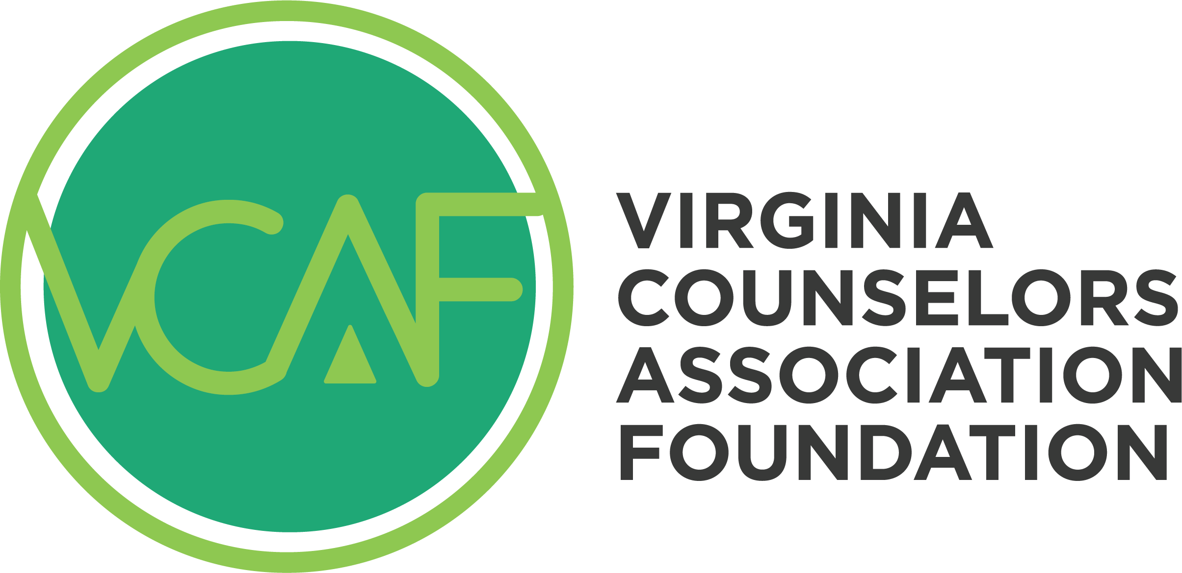

Pete Warren Student Fellows

2026 Scholarship Application

Directions:
- Please complete the required information below, including the essay.
- Save the Word document to your computer with the title as your last name, first name.
- Create an email to Linda Grubba at vcalindagrubba@gmail.com.
- Attach a copy of the final document(s) to the email.
- Submit your document no later than 11:59 p.m. on Sunday, March 1, 2026.

Applicants will receive an email confirming receipt of their application. Applicants will receive a message regarding the decision by March 31, 2026.

Part I: Personal Information

Full Name (First, Middle, Last): ___________________________________________________

Street Address: _______________________________________________________________

City: ______________________________________ State: _________ ZIP: ______________

College Email: ________________________________ Phone: _________________________

Name of College/University: _____________________________________________________

Name of Graduate Program: _____________________________________________________

Degree Goal: Master’s _________________________ Doctorate ________________________

Total Number of Completed Program Credits: _______________________________________

To qualify for a VCA Foundation Pete Warren Student Fellows Scholarship, the Foundation needs to confirm that the student is in good standing. By providing the name of your sponsoring faculty and contact information, you are giving the VCA Foundation permission to request this information from a sponsoring professor of your counseling program.
Note: The sponsoring faculty member must be a full-time instructor in the counseling department.

Name of Sponsoring Faculty: ____________________________________________________

Sponsoring Faculty Phone Number: _______________________________________________

Sponsoring Faculty Email: _______________________________________________________

Part II: Write a Short Essay
In no more than 1200 words, please discuss all of the following topics:
- Your interest and experience in leadership for the counseling profession.
- Your future interest in professional counseling in the state of Virginia.
- Your academic success in graduate school.
- Your view on critical ethical values for our profession.
- Your perspective on multiculturalism and diversity.

The Award:

Students awarded a Virginia Counselors Association Foundation Pete Warren Student Fellows Scholarship will receive the following:
- Paid membership in the Virginia Counselors Association for the fellowship year.
- Paid membership in the student’s VCA Chapter for the fellowship year.
- Paid membership in the student’s choice of one of VCA’s specialty Divisions for the fellowship year.
- Paid registration for the VCA Convention for the fellowship year.
- A $100 stipend, awarded after VCA Convention attendance.
- Paid registration for attendance at the VCA Leadership Academy for fellowship year.
- Recognition in VCA and VCAF publications and at the VCA Convention.

Questions about the Pete Warren Student Fellows Scholarship can be addressed to Linda Grubba via email at vcalindagrubba@gmail.com.

