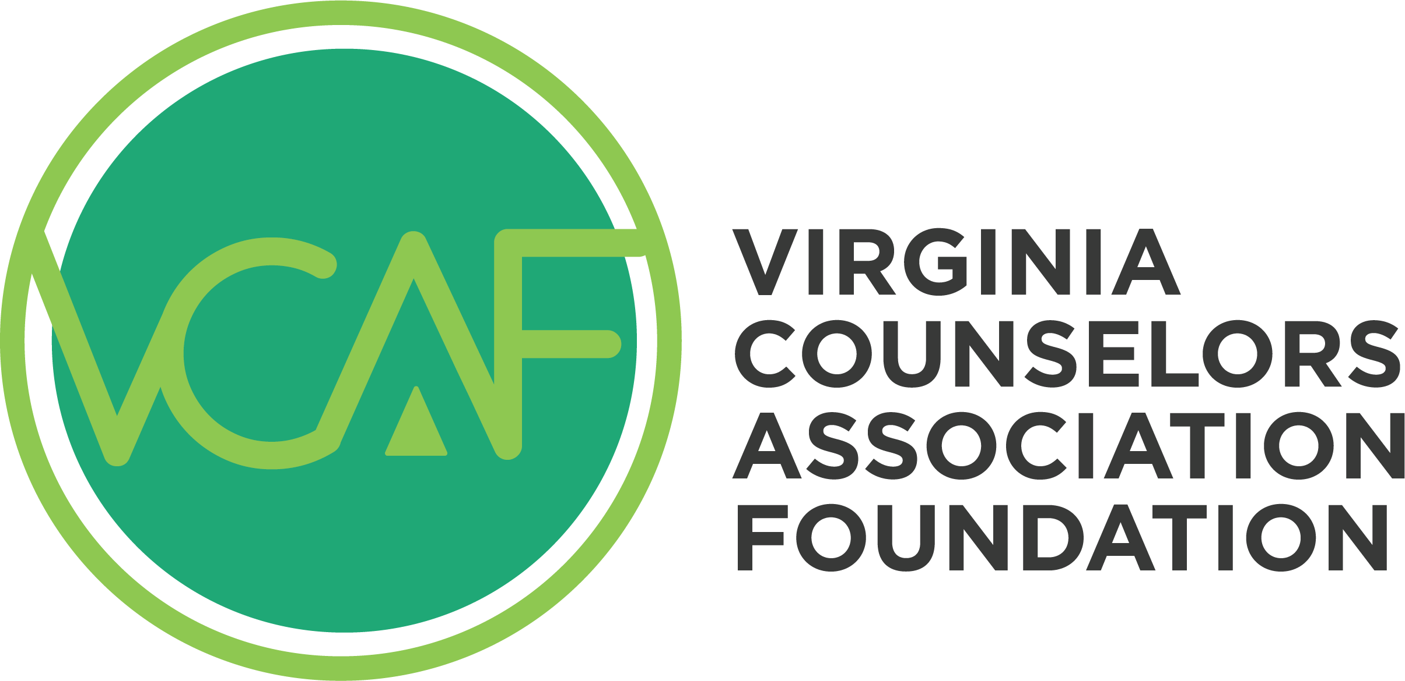

John Cook Award

Nomination

Directions:
- Please complete all the required information below.
- Deliver this completed form and attachments via email to Linda Grubba.
- Submit full, finalized submissions by 11:59 p.m. on the due date.

Applicants will receive an email confirming receipt of their application and a message regarding the decision.

Part I: Nominee Information

Full Name (First, Last): _________________________________________________________

Mailing Address: ______________________________________________________________

City: _______________________________________ State: _________ ZIP: ______________

Email: ______________________________________ Phone: __________________________

Part II: Submitter’s Information

Your Name (First, Last): ________________________________________________________
Your Email:_____________________________________ Phone: _______________________
Organization Affiliation (chapter, division, VCA, foundation): ____________________________
____________________________________________________________________________

Has the organization’s elected board of directors formally endorsed the nominee? ___________

____________________________________________________________________________

Part III: Additional Requirements:
Please gather and attach the following items:

- A letter of recommendation from a VCA member who knows the nominee and is familiar the John Cook Award and the foundation.
- A photo of the nominee that will be used in all announcements.
- The current resume of the nominee featuring service to the VCA, VCA Foundation and/or other organizations associated with the counseling profession.

Questions should be sent to Linda Grubba via email.

